SnekAlerts Supports coverage on DEXes that Frigid supports including:
- Minswap v1 (buys & sells)
- Minswap v2 (buys & sells)
- Sundaeswap v3 (buys & sells)
- Wingriders v1 (buys & sells)
- Wingriders v2 (buys & sells)
- VyFi (buys & sells)
- Splash (buys & sells)

From hereon, this document demonstrates proof that a buy that was performed on February 6 on the Minswap DEX – 35,000 ADA was used to buy 5,600,376 SNEK tokens.
The hash of the transaction is:
bef79fb57ac3f7cdfaff45838dfe0fe3f606f10fccd95f80bb282ecef55b42e8 – Link to cardanoscan
SNEKAlerts was designed to pick up buys above a certain threshold, in our case, 20,000 ADA, and announce them across social media platforms that include X, Discord and Telegram. Proofs across each social media for this hash showcasing the purchase of SNEK tokens can be seen in the next page.
The logs across each proof can be cross-referenced by the GitHub repository below that is private access – please request access should you want to check out our code that creates these social media posts!
https://github.com/Iceberg-labs/SnekAlerts
The private repo includes code only with a basic README file to explain the basics of what this system does. Otherwise, all the documentation for proofs can be found in this document and the logs cross-referenced with the source in the private repo above.
Proof #1 – TG + Logs
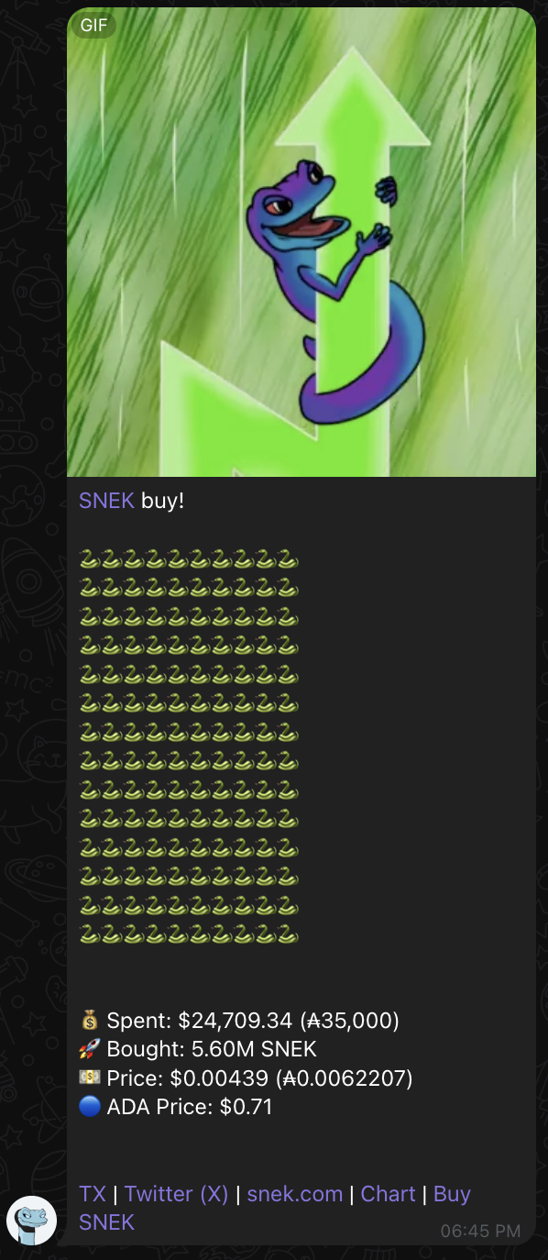
Public link to message
Proof #2 – Twitter + Logs
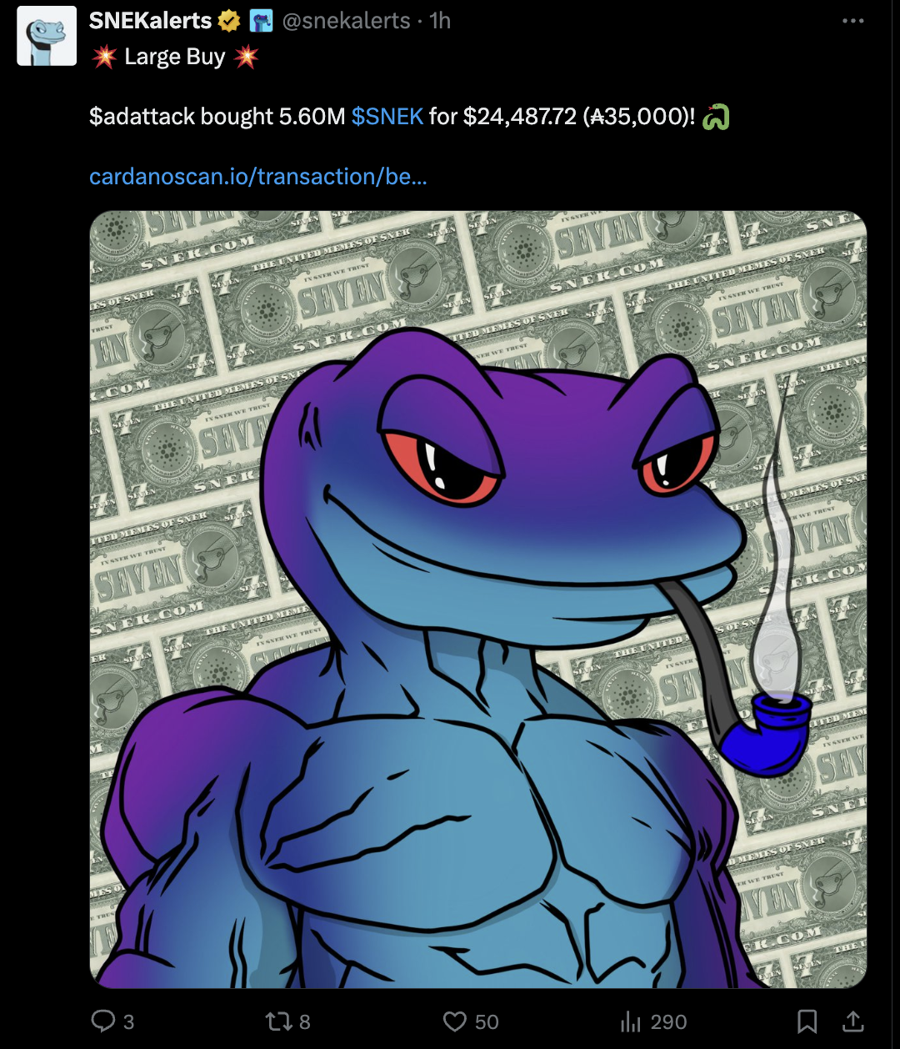
Link to tweet
Proof #3 – Discord + Logs – note, cross-posting on discord and twitter is via the same system in this iteration
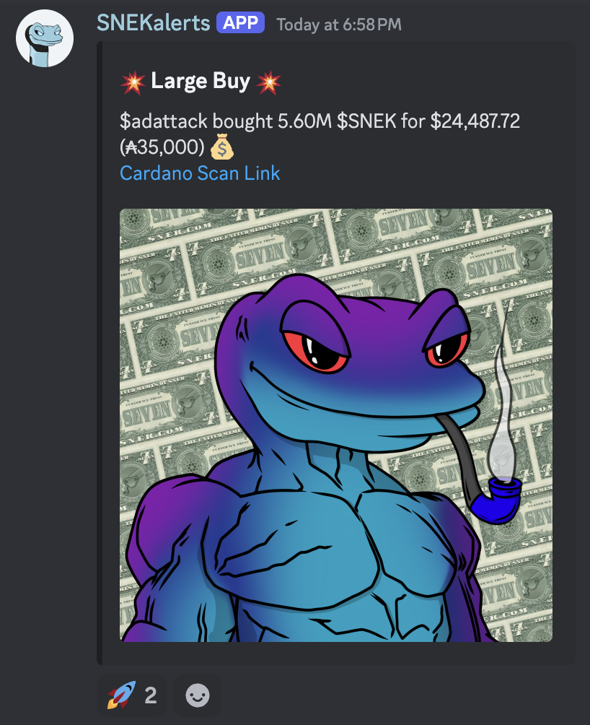
Public link to message (must be on Snek discord to access)

Comparison of this buy with another source (TapTools):
Source (TapTools Pro access required)

Comparison of this buy with another source 2 (minswap – where order was placed):
Source (Need to set filter for “buy” & February 6)

